Green Society Public School
D-21
Ratnanagar-7, Sauraha, Chitwan
Third Terminal Examination-2082
Class: Nursery Time: - 2 hrs. F.M.: 50
Sub: English ‘O’
- What is your name? 5
- How are you? 5
- In which class do you read? 5
- How old are you? 5
- What is your principal's name? 5
- What is our national flower name? 5
- Read the given letters? 10
Kk Ll Mm Nn Oo
Pp Qq Rr Ss Tt
- Identify the pictures. 5
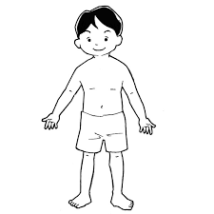
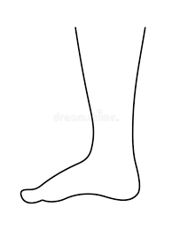


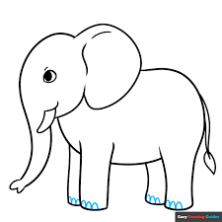
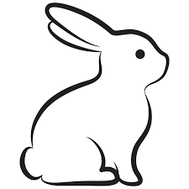

- Neat and clean. 10

